**Assignment No: 02**

**Create an android Calculator app with Interactive User Interface using appropriate layouts.**

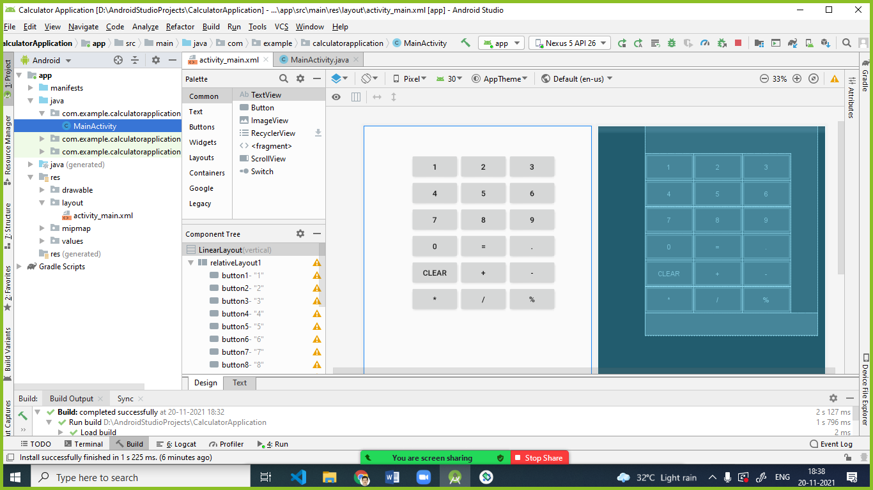

bnutton1

**Layout used:**

1. LinearLayout
2. RelativeLayout

**Code: -**

**activity_main.xml:**

*<?*xml version="1.0" encoding="utf-8"*?>*<LinearLayout xmlns:android="http://schemas.android.com/apk/res/android"  
 android:layout_width="fill_parent"  
 android:layout_height="fill_parent"  
 android:orientation="vertical">  
 <RelativeLayout  
 android:id="@+id/relativeLayout1"  
 android:layout_width="312dp"  
 android:layout_height="wrap_content"  
 android:layout_gravity="center"  
 android:layout_marginLeft="35dp">  
  
 <Button  
 android:id="@+id/button1"  
 android:layout_width="wrap_content"  
 android:layout_height="wrap_content"  
 android:layout_alignParentLeft="true"  
 android:layout_marginTop="150dp"  
 android:padding="20px"  
 android:text="1"></Button>  
  
 <Button  
 android:id="@+id/button2"  
 android:layout_width="wrap_content"  
 android:layout_height="wrap_content"  
 android:layout_alignTop="@+id/button1"  
 android:layout_alignParentLeft="true"  
 android:layout_marginLeft="89dp"  
 android:layout_marginTop="0dp"  
 android:layout_toRightOf="@+id/button1"  
 android:padding="20px"  
 android:text="2"></Button>  
  
 <Button  
 android:id="@+id/button3"  
 android:layout_width="wrap_content"  
 android:layout_height="wrap_content"  
 android:layout_alignTop="@+id/button2"  
 android:layout_marginLeft="2dp"  
 android:layout_marginTop="0dp"  
 android:layout_toRightOf="@+id/button2"  
 android:padding="20px"  
 android:text="3"></Button>  
  
 <Button  
 android:id="@+id/button4"  
 android:layout_width="wrap_content"  
 android:layout_height="wrap_content"  
 android:layout_alignParentLeft="true"  
 android:layout_below="@+id/button1"  
 android:padding="20px"  
 android:text="4"></Button>  
 <Button  
 android:id="@+id/button5"  
 android:layout_width="wrap_content"  
 android:layout_height="wrap_content"  
 android:layout_alignTop="@+id/button4"  
 android:layout_toRightOf="@+id/button4"  
 android:padding="20px"  
 android:text="5"></Button>  
 <Button  
 android:id="@+id/button6"  
 android:layout_width="wrap_content"  
 android:layout_height="wrap_content"  
 android:layout_alignTop="@+id/button4"  
 android:layout_toRightOf="@+id/button5"  
 android:padding="20px"  
 android:text="6"></Button>  
 <Button  
 android:id="@+id/button7"  
 android:layout_width="wrap_content"  
 android:layout_height="wrap_content"  
 android:layout_alignParentLeft="true"  
 android:layout_below="@+id/button4"  
 android:padding="20px"  
 android:text="7"></Button>  
 <Button  
 android:id="@+id/button8"  
 android:layout_width="wrap_content"  
 android:layout_height="wrap_content"  
 android:layout_alignTop="@+id/button7"  
 android:layout_toRightOf="@+id/button7"  
 android:padding="20px"  
 android:text="8"></Button>  
 <Button  
 android:id="@+id/button9"  
 android:layout_width="wrap_content"  
 android:layout_height="wrap_content"  
 android:layout_alignTop="@+id/button7"  
 android:layout_toRightOf="@+id/button8"  
 android:padding="20px"  
 android:text="9"></Button>  
 <Button  
 android:id="@+id/button0"  
 android:layout_width="wrap_content"  
 android:layout_height="wrap_content"  
 android:layout_alignParentLeft="true"  
 android:layout_below="@+id/button7"  
 android:padding="20px"  
 android:text="0"></Button>  
 <Button  
 android:id="@+id/button15"  
 android:layout_width="wrap_content"  
 android:layout_height="wrap_content"  
 android:layout_alignTop="@+id/button0"  
 android:layout_toRightOf="@+id/button0"  
 android:padding="20px"  
 android:text="="></Button>  
 <Button  
 android:id="@+id/button18"  
 android:layout_width="wrap_content"  
 android:layout_height="wrap_content"  
 android:layout_alignTop="@+id/button0"  
 android:layout_toRightOf="@+id/button15"  
 android:padding="20px"  
 android:text="."></Button>  
 <Button  
 android:id="@+id/button16"  
 android:layout_width="wrap_content"  
 android:layout_height="wrap_content"  
 android:layout_alignParentLeft="true"  
 android:layout_below="@+id/button0"  
 android:padding="20px"  
 android:text="clear"></Button>  
 <Button  
 android:id="@+id/button11"  
 android:layout_width="wrap_content"  
 android:layout_height="wrap_content"  
 android:layout_alignTop="@+id/button16"  
 android:layout_toRightOf="@+id/button16"  
 android:padding="20px"  
 android:text="+"></Button>  
 <Button  
 android:id="@+id/button12"  
 android:layout_width="wrap_content"  
 android:layout_height="wrap_content"  
 android:layout_alignTop="@+id/button16"  
 android:layout_toRightOf="@+id/button11"  
 android:padding="20px"  
 android:text="-"></Button>  
 <Button  
 android:id="@+id/button13"  
 android:layout_width="wrap_content"  
 android:layout_height="wrap_content"  
 android:layout_alignParentLeft="true"  
 android:layout_below="@+id/button16"  
 android:padding="20px"  
 android:text="*"></Button>  
 <Button  
 android:id="@+id/button14"  
 android:layout_width="wrap_content"  
 android:layout_height="wrap_content"  
 android:layout_alignTop="@+id/button13"  
 android:layout_toRightOf="@+id/button13"  
 android:padding="20px"  
 android:text="/"></Button>  
 <Button  
 android:id="@+id/button17"  
 android:layout_width="wrap_content"  
 android:layout_height="wrap_content"  
 android:layout_alignTop="@+id/button13"  
 android:layout_toRightOf="@+id/button14"  
 android:padding="20px"  
 android:text="%"></Button>  
 <TextView  
 android:id="@+id/TextView1"  
 android:layout_width="fill_parent"  
 android:layout_height="wrap_content"  
 android:layout_below="@+id/button13"  
 android:fontFamily="serif"  
 android:textSize="30dp"></TextView>  
  
 </RelativeLayout>  
</LinearLayout>

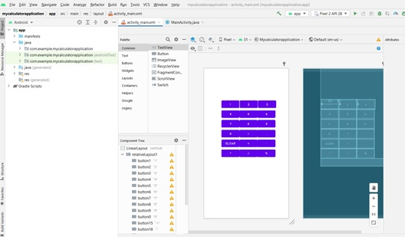

**MainAtivity.java:**  
  
import androidx.appcompat.app.AppCompatActivity;  
  
import android.os.Bundle;  
import android.view.View;  
import android.widget.Button;  
import android.widget.TextView;  
import android.widget.Toast;  
  
public class MainActivity extends AppCompatActivity {  
 TextView tv1;  
 Integer c,d,r,b;  
 String a = "0", aa;  
 Button b1,b2,b3,b4,b5,b6,b7,b8,b9,b10,b11,b12,b13,b14,b15,b16,b17,b18;  
  
 @Override  
 protected void onCreate(Bundle savedInstanceState) {  
 super.onCreate(savedInstanceState);  
 setContentView(R.layout.*activity_main*);  
 tv1 = (TextView) findViewById(R.id.*TextView1*);  
 b1 = (Button) findViewById(R.id.*button1*);  
 b2 = (Button) findViewById(R.id.*button2*);  
 b3 = (Button) findViewById(R.id.*button3*);  
 b4 = (Button) findViewById(R.id.*button4*);  
 b5 = (Button) findViewById(R.id.*button5*);  
 b6 = (Button) findViewById(R.id.*button6*);  
 b7 = (Button) findViewById(R.id.*button7*);  
 b8 = (Button) findViewById(R.id.*button8*);  
 b9 = (Button) findViewById(R.id.*button9*);  
 b10 = (Button) findViewById(R.id.*button0*);  
 b11 = (Button) findViewById(R.id.*button11*);  
 b12 = (Button) findViewById(R.id.*button12*);  
 b13 = (Button) findViewById(R.id.*button13*);  
 b14= (Button) findViewById(R.id.*button14*);  
 b15= (Button) findViewById(R.id.*button15*);  
 b16= (Button) findViewById(R.id.*button16*);  
 b17= (Button) findViewById(R.id.*button17*);  
 b18= (Button) findViewById(R.id.*button18*);  
  
 b1.setOnClickListener(new View.OnClickListener() {  
 public void onClick(View v) {  
 a = tv1.getText().toString();  
 a = a + "1";  
 tv1.setText(a);  
 }  
 });  
 b2.setOnClickListener(new View.OnClickListener() {  
 public void onClick(View v) {  
 a = tv1.getText().toString();  
 a = a + "2";  
 tv1.setText(a);  
 }  
 });  
 b3.setOnClickListener(new View.OnClickListener() {  
 public void onClick(View v) {  
 a = tv1.getText().toString();  
 a = a + "3";  
 tv1.setText(a);  
 }  
 });  
 b4.setOnClickListener(new View.OnClickListener() {  
 public void onClick(View v) {  
 a = tv1.getText().toString();  
 a = a + "4";  
 tv1.setText(a);  
 }  
 });  
 b5.setOnClickListener(new View.OnClickListener() {  
 public void onClick(View v) {  
 a = tv1.getText().toString();  
 a = a + "5";  
 tv1.setText(a);  
 }  
 });  
 b6.setOnClickListener(new View.OnClickListener() {  
 public void onClick(View v) {  
 a = tv1.getText().toString();  
 a = a + "6";  
 tv1.setText(a);  
 }  
 });  
 b7.setOnClickListener(new View.OnClickListener() {  
 public void onClick(View v) {  
 a = tv1.getText().toString();  
 a = a + "7";  
 tv1.setText(a);  
 }  
 });  
 b8.setOnClickListener(new View.OnClickListener() {  
 public void onClick(View v) {  
 a = tv1.getText().toString();  
 a = a + "8";  
 tv1.setText(a);  
 }  
 });  
 b9.setOnClickListener(new View.OnClickListener() {  
 public void onClick(View v) {  
 a = tv1.getText().toString();  
 a = a + "9";  
 tv1.setText(a);  
 }  
 });  
 b10.setOnClickListener(new View.OnClickListener() {  
 public void onClick(View v) {  
 a = tv1.getText().toString();  
 a = a + "0";  
 tv1.setText(a);  
 }  
 });  
 b11.setOnClickListener(new View.OnClickListener() {  
 public void onClick(View v) {  
 aa = a;  
 b = 1;  
 a = "";  
 *//tv1.setText(+);* tv1.setText("");  
 }  
 });  
 b12.setOnClickListener(new View.OnClickListener() {  
 public void onClick(View v) {  
 aa = a;  
 b = 2;  
 a = "";  
 *//tv1.setText(a);* tv1.setText("-");  
 tv1.setText("");  
 }  
 });  
 b13.setOnClickListener(new View.OnClickListener() {  
 public void onClick(View v) {  
 aa = a;  
 b = 3;  
 a = "";  
 *//tv1.setText(a);* tv1.setText("*");  
 tv1.setText("");  
 }  
 });  
 b14.setOnClickListener(new View.OnClickListener() {  
 public void onClick(View v) {  
 aa = a;  
 b = 4;  
 a = "";  
 *//tv1.setText(a);* tv1.setText("/");  
 tv1.setText("");  
 }  
 });  
 *//OnClickevent handling for =* b15.setOnClickListener(new View.OnClickListener() {  
 public void onClick(View v) {  
 if (b == 1){  
 c = Integer.*parseInt*(aa);  
 d = Integer.*parseInt*(a);  
 r = c + d;  
 } else if (b == 4){  
 c = Integer.*parseInt*(aa);  
 d = Integer.*parseInt*(a);  
 r = c/d;  
 } else if (b == 2){  
 c = Integer.*parseInt*(aa);  
 d = Integer.*parseInt*(a);  
 r = c - d;  
 } else if (b == 3) {  
 c = Integer.*parseInt*(aa);  
 d = Integer.*parseInt*(a);  
 r = c * d;  
 }  
 String op ="";  
 switch (b) {  
 case 1: op = " + ";  
 break;  
 case 2: op = " - ";  
 break;  
 case 3: op = " * ";  
 break;  
 case 4: op = " / ";  
 }  
 tv1.setText(c + op + d + " = " + r);  
 String ans=c + op + d + " = " + r;  
 Toast.*makeText*(MainActivity.this, ans, Toast.*LENGTH_LONG*).show();  
  
 }  
 });  
 b16.setOnClickListener(new View.OnClickListener() {  
 public void onClick(View v) {  
 tv1.setText("");  
 }  
 });  
  
 }

}

**Output:**

